# Flood monitoring and early warning system

Name : Bhanusri G

Reg no : 952021106001

Team : Sri Jaya Jothi M

Brindha R A

Divya R

# Objective:

The main objectives of the project are:

• To read the temperature and humidity of the environment continuously

• To warn the people through SMS system using web API

• To detect the level of water in real time.

# Scope:

The main purpose of application is to know the nearest flood situation.

# Flood monitoring:

The purpose of this project is to sense the water level in river beds and check if they are in normal condition. If they reach beyond the limit, then it alerts people through LED signals and buzzer sound. Also it alerts people through SMS and Emails alerts when the water level reaches beyond the limit.

#### Hardware components :

1. Bolt-IoT Wifi module
2. Arduino uno
3. Breadboard- 400 tie points
4. 5mm LED:(Green, Red, Orange) and Buzzer
5. 16×2 LCD Display
6. LM35 Temperature Sensor
7. HC-SR04 Ultrasonic Sensor
8. Some Jumper Wires
   1. Male to Female Jumper Wires- 15 pcs
   2. Male to Male Jumper Wires- 10 pcs
   3. Female to Female Jumper Wires- 5 pcs
9. 9v Battery and Snap Connector and USB cable type B

#### Hand tools and fabrication machines:

1. Electrical Tape
2. Green Cello Tape

Steps to connect the components:

**Step 1**: **Connecting 5v and GND of Arduino to the Breadboard for power connection to other components.**

**Step 2**: **Connecting LED’s**

**Step 3**: **Connecting Buzzer**

**Step 4**: **Connecting HC-SR04 Ultrasonic Sensor**

**Step 5: Connecting Bolt WiFi Module**

**Step 6: Connecting LM35 Temperature Sensor**

**Step 7:Connecting 16×2 LCD  Display**

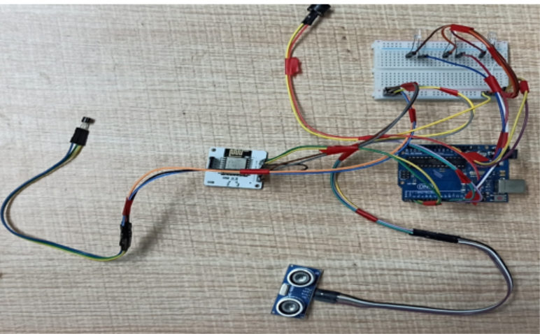

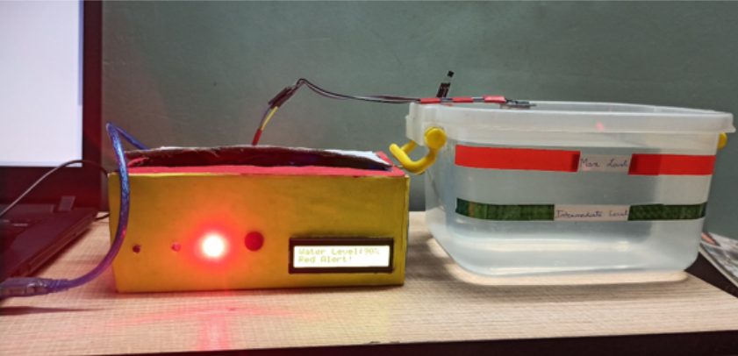

When water level crosses the Max Level. That resembles ‘Red Alert’. This means that water level has crossed the 80% and flood situation has occured at that place. With increase in water level the system sends SMS and Email alerts to the authority or registered user from Twillo and Mailgun Services respectively. Also red led will glow and buzzer will buzz for two times. It will also show red alert in Lcd display.

Programming for flood monitoring

//IOT Based Flood Monitoring And Alerting System.

#include<LiquidCrystal.h>

LiquidCrystal lcd(2, 3, 4, 5, 6, 7);

const int in = 8;

const int out = 9;

const int green = 10;

const int orange = 11;

const int red = 12;

const int buzz = 13;

void setup() {

Serial.begin(9600);

lcd.begin(16, 2);

pinMode( in , INPUT);

pinMode(out, OUTPUT);

pinMode(green, OUTPUT);

pinMode(orange, OUTPUT);

pinMode(red, OUTPUT);

pinMode(buzz, OUTPUT);

digitalWrite(green, LOW);

digitalWrite(orange, LOW);

digitalWrite(red, LOW);

digitalWrite(buzz, LOW);

lcd.setCursor(0, 0);

lcd.print("Flood Monitoring");

lcd.setCursor(0, 1);

lcd.print("Alerting System");

delay(5000);

lcd.clear();

}

void loop() {

long dur;

long dist;

long per;

digitalWrite(out, LOW);

delayMicroseconds(2);

digitalWrite(out, HIGH);

delayMicroseconds(10);

digitalWrite(out, LOW);

dur = pulseIn( in , HIGH);

dist = (dur * 0.034) / 2;

per = map(dist, 10.5, 2, 0, 100);

#map

function is used to convert the distance into percentage.

if(per < 0) {

per = 0;

}

if (per > 100) {

per = 100;

}

Serial.println(String(per));

lcd.setCursor(0, 0);

lcd.print("Water Level:");

lcd.print(String(per));

lcd.print("% ");

if (per >= 80) #MAX Level of Water--Red Alert!{

lcd.setCursor(0, 1);

lcd.print("Red Alert! ");

digitalWrite(red, HIGH);

digitalWrite(green, LOW);

digitalWrite(orange, LOW);

digitalWrite(buzz, HIGH);

delay(2000);

digitalWrite(buzz, LOW);

delay(2000);

digitalWrite(buzz, HIGH);

delay(2000);

digitalWrite(buzz, LOW);

delay(2000);

}

else if (per >= 55) #Intermedite Level of Water--Orange Alert!{

lcd.setCursor(0, 1);

lcd.print("Orange Alert! ");

digitalWrite(orange, HIGH);

digitalWrite(red, LOW);

digitalWrite(green, LOW);

digitalWrite(buzz, HIGH);

delay(3000);

digitalWrite(buzz, LOW);

delay(3000);

}

else #MIN / NORMAL level of Water--Green Alert!{

lcd.setCursor(0, 1);

lcd.print("Green Alert! ");

digitalWrite(green, HIGH);

digitalWrite(orange, LOW);

digitalWrite(red, LOW);

digitalWrite(buzz, LOW);

}

delay(15000);

}

Simulation output:

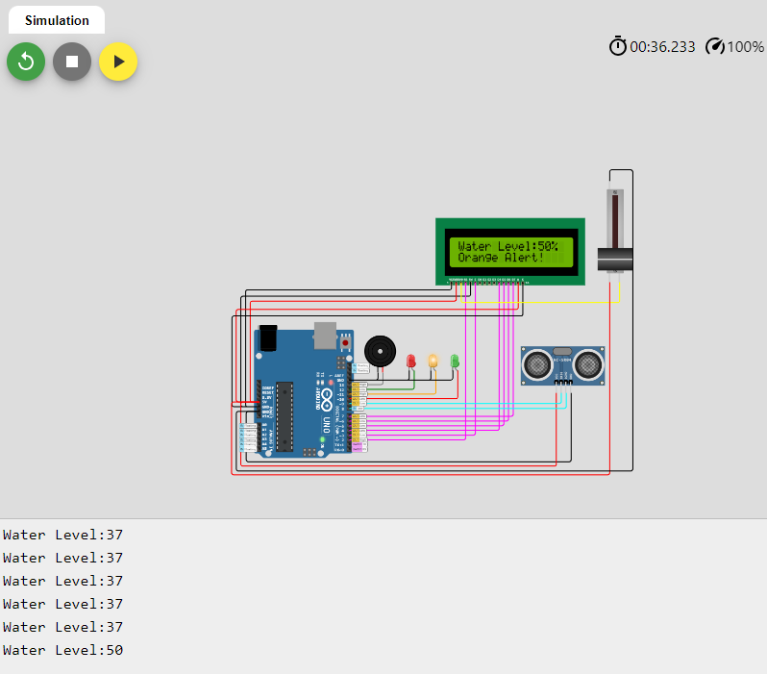

# Conclusion:

Nowadays the Internet Of things (IoT) is broadly used in worldwide, this system will display the data of the water level measured on lcd display. This project can be very helpful to the Meteorological Department to continuously monitor the dams and river beds water level. With this project it can save many people lives by giving alerts when the water level crosses beyond the limit. This project is very cost-effective, flexible and productive in areas where flood conditions happens everytime.